Project Design Phase-II Technology Stack - Architecture & Stack

|  |  |
| --- | --- |
| Date | 25 OCT2022 |
| Team ID | PNT2022TMID42048 |
| Project Name | Project - Intelligent Vehicle Damage Assessment & Cost Estimator for Insurance Companies |
| Maximum Marks | 4 |

# Technical Architecture:

The Deliverable shall include the architectural diagram as below and the information as per the table1 and table 2

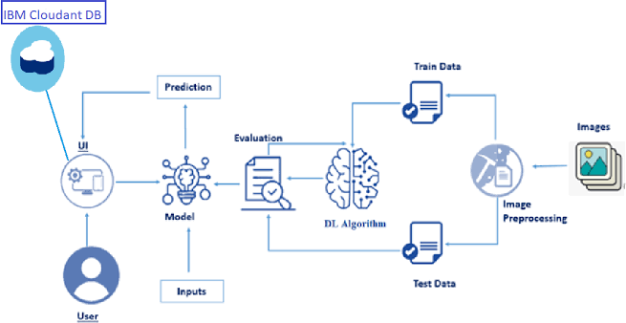

# Table 1: Components and Technologies

|  |  |  |  |
| --- | --- | --- | --- |
| **S. No** | **Component** | **Description** | **Technology** |
| 1. | User Interface | How the user interacts  with application. e.g. Web UI | HTML and CSS |
| 2. | Application Logic-1 | Handle all the user requests done through the Web UI / Display the  results after process | Python Flask Server |
| 3. | Application Logic-2 | Process the image provided by the user via  Web UI | Python |
| 4. | Application Logic-3 | Train the model and provide the classification result for the image given as input | IBM Watson Studio |
| 5. | Cloud Database | Database Service on Cloud | IBM DB2, IBM Cloudant etc. |
| 6. | File Storage | File storage requirements | Local Filesystem |
| 7. | Machine Learning Model | Purpose of Machine Learning Model | VGG16 Pre-Trained Model |
| 8. | Infrastructure (Server / Cloud) | Application Deployment on Local System | Local |

**Table-2: Application Characteristics:**

|  |  |  |  |
| --- | --- | --- | --- |
| **S. No** | **Characteristics** | **Description** | **Technology** |
| 1. | Open-Source Frameworks | List the open-source frameworks used | Flask, TensorFlow, Keras  , NumPy, OpenCV |
| 2. | Security Implementations | List all the security / access controls implemented, use of  firewalls etc. | IAM Controls |

|  |  |  |  |
| --- | --- | --- | --- |
| 3. | Scalable Architecture | Justify the scalability of architecture (3 – tier,  Micro-services) | 3-tier type (Web server, App server and DB  server). |
| 4. | Availability | Justify the availability of application (e.g. use of load balancers, distributed servers etc.) | Local: Available based on computer’s specs. Cloud: Web server, DB server available when requested. App server requires high requirements compared with other 2 servers, thereby availability is bit less but can be  compensated by cloud |
| 5. | Performance | Design consideration for the performance of the application (number of requests per sec, use of Cache, use of CDN’s) etc. | Accuracy of model:  >85% (Expected) Number of requests per second: 250 – 1000 (based on network traffic, 250 is default as targeted user group is  moderate) |